**Persisting Bags and IdBags**

If we wish to have an unordered collection and no indexing of the elements, Java doesn’t have any data structure that supports that. The closest is *java.util.List*, but obviously it maintains both order and indexing. To stratify this requirement, Hibernate created a special type of collection called *bags.*

*Bags* are the opposite of lists: they are unordered and nonindexed collection that allow duplicate elements. *Bags* are unique to Hibernate, and there is no equivalent collection in the java space.

Implementing bags is very simple; we don’t notice any difference to our entities. In fact, we could still be using *List* to represent the bag in the Java code (remember, there is no bags collection in Java). The actual difference appears in the mapping side. Instead of declaring the collection as a *list,* we use *bag.*

See the following mapping definition, with no changes to entities:

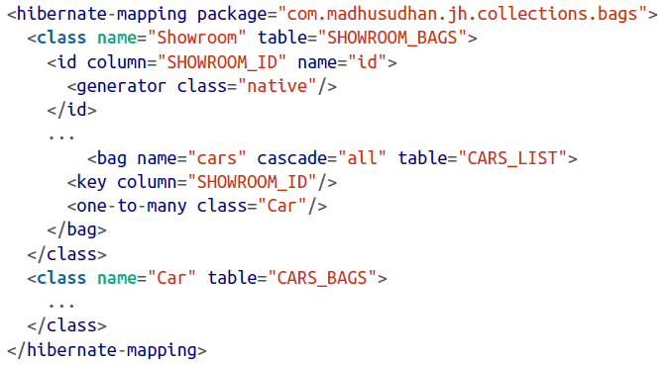

In the bag element, did you notice we dropped the index element that must exist in the *list* definition? In bags, the index of the collection is not persisted anymore; hence, you won’t see the *index* element defined in the mapping.

Apart from this difference, the rest of the mechanics for running the tests is exactly the same as with lists. The test class defined here shows how we populate the data before persisting the entity:

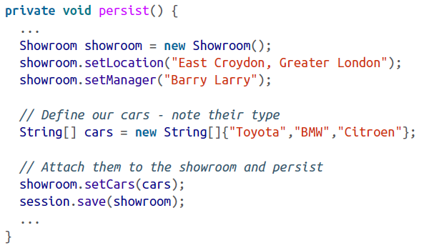

Bags are not a standard collection; they are Hibernate-specific. Although your code still uses *java.util.List* for a bag, the mapping needs to be explicit. It’s better to stay away from bags if possible, and choose standard collections wherever you can.



In addition to bags, Hibernate supports *idbags,* a collection that provides a mechanism to have a *surrogate key* on the persisted collection itself, unlike bags where no key exists. As usual, the POJOs will not be changed, but the mapping deserves special attention:

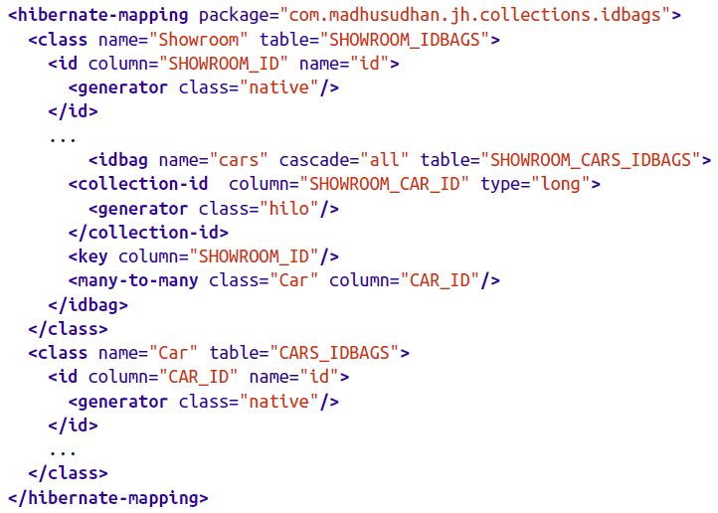

Here we introduce the *idbags* element to represent our *cars* collection, pointing to a join table, SHOWROOM_CARS_IDBAGS. The *collection-id* element creates a primary key on the join table. In addition to its own primary key, the join table will also carry primary keys from the other two tables.

